**CIS 572 Object Oriented System Design**

**Forward Tracing**

for

**Report Extraction**



Submitted to:  Mr. Thomas Steiner

~~Submitted by: Kopal Shinde~~

~~UMID 20780248~~

**Table of Contents**

USE CASE FLOW **3**

ACTIVITY & USE CASE DIAGRAMS **3**

BUILD ERD **4**

DFD **5**

COMMUNICATION DIAGRAM **5**

SEQUENCE DIAGRAM **6**

CLASS DIAGRAM **7**

CRC CARD **7**

# 1. USE CASE FLOW

* 1. **Manager receives the Summary Report**:

1. The report is requested by Manager at any time.
2. The system generates the Report at any time.
3. The manager receives the Report.

## 

# 2. ACTIVITY ~~USE CASE~~ DIAGRAM

**[Diagram below was deleted]**

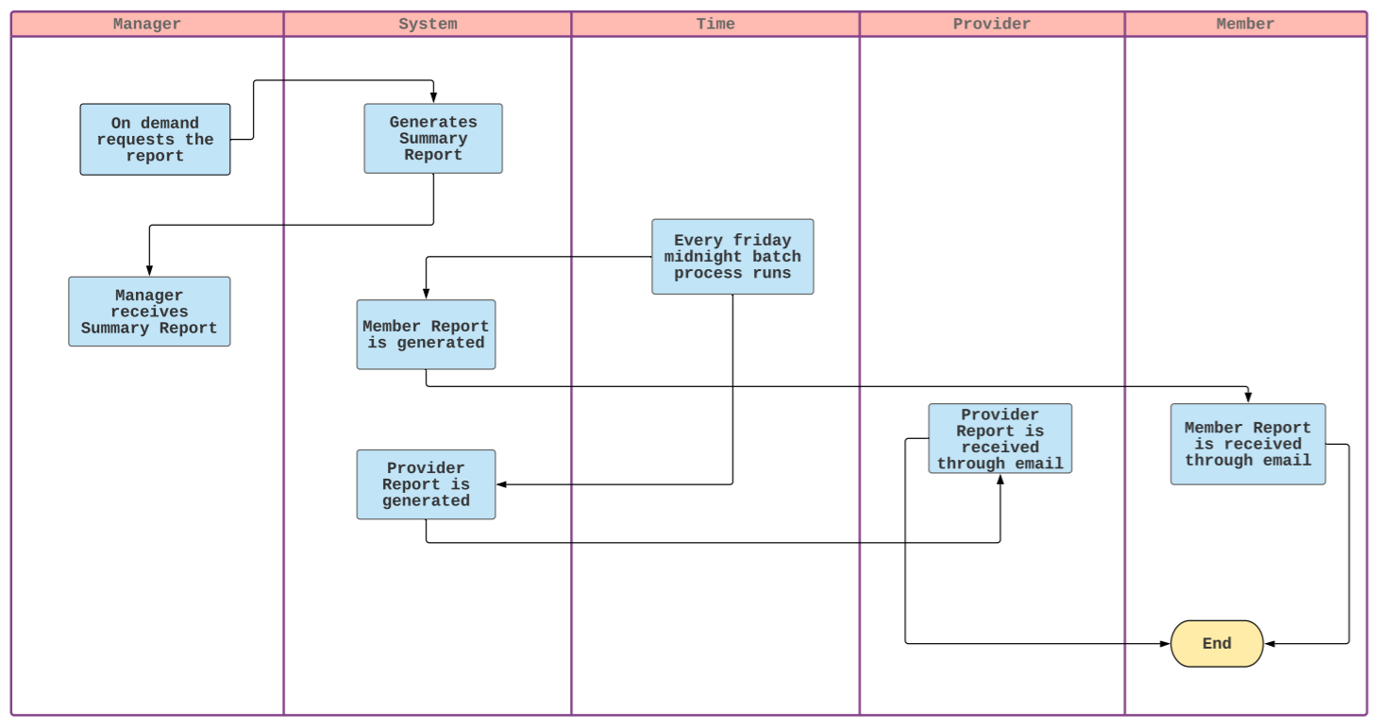  
**USE CASE DIAGRAM**

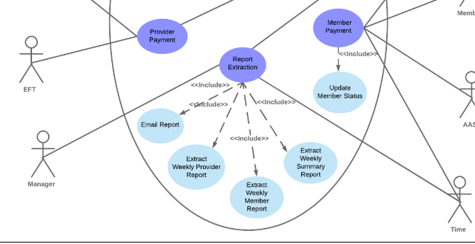

# BUILD ERD

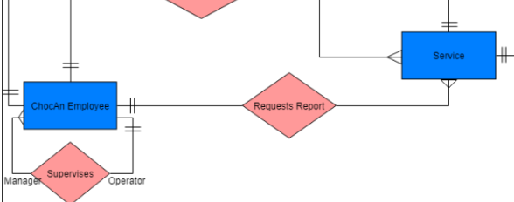

# 0 LEVEL DFD [DIAGRAM BELOW WAS DELETED]

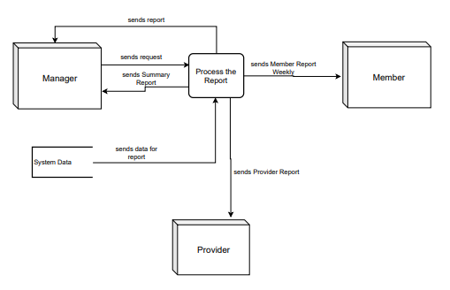

# COMMUNICATION DIAGRAM

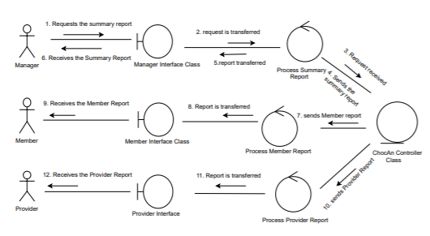

# SEQUENCE DIAGRAM

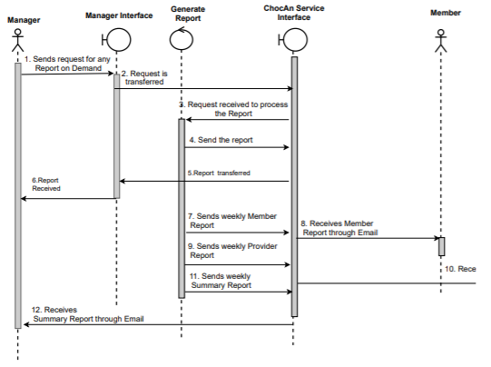

# CLASS DIAGRAM

[DIAGRAM BELOW WAS DELETED]

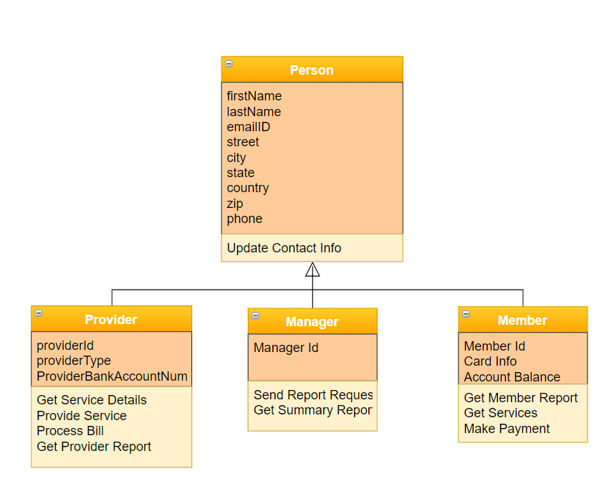

# CRC CARD

